Bitflash Robotics
Arduino program style guide

Libraries
Libraries are to be included at the top of a given sketch. They are to be defined with no indentation. Comments must be inline. Library inclusions should be seperated from the rest of the code by at least 3 blank lines.
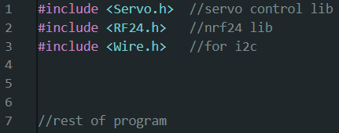

Definitions
Definitions are to be placed in blocks below the library inclusion statements. Definitions should be in CAPITAL_SNAKE_CASE. They should be formatted first with the type of data being defined as a 3 letter acronym.
CMD | Command
STT | State
UDF | User-definition
MDE | Mode
CST | Constant
PIN | Pin
DFT | Default value
Multiple data types can be stacked, with this table being a heirarchy of which should appear first in the list. For example: UDF_MDE_ESC_TYPE. Following the data type must be the defined value in any form. If measurements are used, the units should be included in the definition name, like UDF_CST_MAXIMUM_COMBINED_ACCEL_G.
Definitions may be grouped into “blocks” similar to regular code. “Blocks” of definitions must be spaced by one line and each “block” should be formatted according to auto-format. Blocks should be spaced from each other by one new line, and spaced from other code by 3 new lines.
User-configurable defines SHOULD be placed in a config.h file, but this is not strictly necessary.
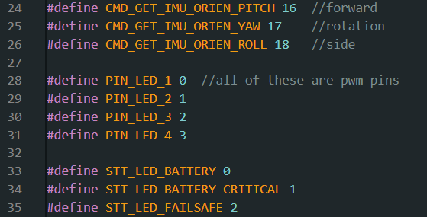

Variables
Variables are to be defined in the standard way. Data types should be grouped together when initializing several variables, but this is not necessary. Variables are to be defined in blocks, with each block relating to a different system of the code.
Blocks are to be separated from each other by 1 new line and from other code by 3 new lines.
Variables are to be defined in snake_case.
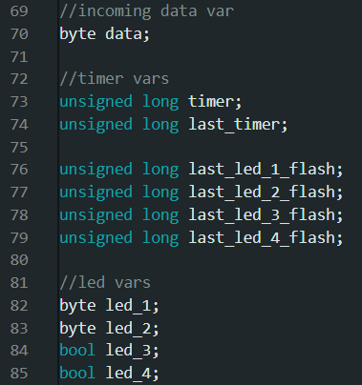

Enums
Enums are to be defined below the variables section. If only one enum is used, enum-specific variables are to be defined directly below the enum definition, spaced by one new line. If multiple are used, the enum definitions are to be listed followed by all variable definitions inside a block.
If multiple enums are used, it may be worth placing the enum’s name inside of each definition value like SETTING_ENTRY_UNDEF in order to prevent conflicts.
All enums should be in snake_case with states in CAPITAL_SNAKE_CASE.
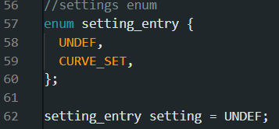

Objects
Objects are to be created after any variables and enums are defined, but before the setup function. Object pins should always use defines. All objects should be in camelCase.

Setup
Setup commands should always be placed in blocks dependent on which systems the commands address. Serial and software serial initializations should always come first. Next should be object, device, and pin setup, and then other code.
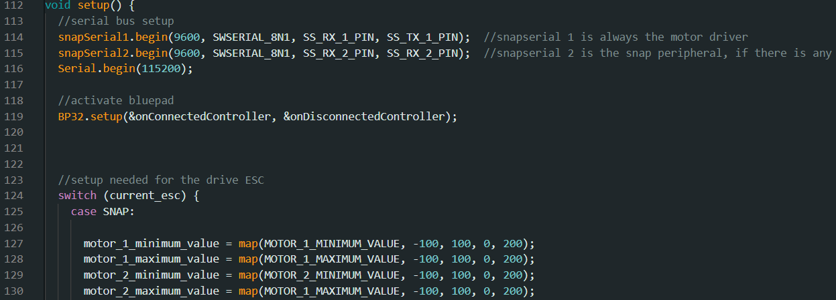

Code Blocks
Blocks in the main loop are to be separated by new lines. Each block should pertain to some subsystem or contain some script or contain some set of related functions, but the exact contents may vary as long as the separation into blocks makes the code more readable. That’s the point of blocks – make the code more readable.
Usually, 1 new line is used to separate related pieces of code, and 3 are used to separate unrelated pieces of code.

Conditionals (If)
Conditionals are always in a single code block. No extra lines should be used between “ifs” and “elses”. However, code blocks can be used inside of conditionals.
Conditional operators should always use symbols instead of names (||, &&, !=, etc).

Switches
Switches are to be set up with each case in its own block. A default option should be included if applicable.

Comments
Inline comments are to be demarcated using 2 forward slashes and placed at least 1 space from the code it references. If a code block contains multiple inline comments, they should be on the same vertical column as according to autoformat.
Block comments should be in their own block, and the contents of the comment must remain as one cohesive whole without requiring text wrapping.

